

**DEPARTMENT of CHILDREN and FAMILIES**

*Making a Difference for Children, Families and Communities*

**Plan for the Closure of the**

**Connecticut Juvenile Training School**

**Submitted by:**

**Fernando J. Muñiz, MPA**

**Deputy Commissioner**

**Department of Children and Families**

**Executive Summary**

The Connecticut Juvenile Training School (CJTS) is a secure facility for young men who have been committed delinquent and placed in the custody of the Department of Children and Families (DCF). The facility opened in 2001 with a maximum capacity of over 230 residents. In the spring of 2016, due to a decreasing number of youth committed delinquent and to policy changes within DCF, the average daily population at CJTS was 48 youth.

CJTS has been a source of public concern almost since the day the facility opened in 2001. The facility was built based on a secure facility in Ohio and its construction played a major part in the scandal that led to the resignation of Governor John Rowland. From the beginning, advocates expressed concerns with the level of security, the programming and the number of restraints at the facility. More recently, there has been an increase in staff injuries and worker’s compensation claims.

In December 2015, Governor Dannel Malloy announced his plan to close CJTS by July 2018. In order to effectuate the closure of CJTS, DCF embarked on an inclusive planning process to close or modify the facility in accordance with the governor’s directive in a manner that accounts for the best interests of the youth served by CJTS.  The plan is informed by national best practices, as well as an analysis of the population of youth currently served by CJTS and the youth who will be impacted by future age related statutory changes.

The closure of CJTS must coincide with other changes in the juvenile justice system in order to meet the needs of the youth committed delinquent to DCF. The environment in which any future facility exists must support serving more youth in the community. Accordingly, the Department’s plan for the closure of CJTS includes recommendations with the goal of continuing to improve the juvenile justice system overall. These include:

1. Redefine eligibility for secure placement;
2. Supporting the use of graduated responses;
3. Preserving non-residential community-based services and supports;
4. Improving community supervision of youth;
5. Right-sizing, redesigning and replacing CJTS with a smaller secure facility.

Many of the recommendations in this plan can be implemented with no-cost or low-cost to the state. In the short-term, the focus should be implementing these no-cost or low-cost changes to policies and practices that will promote better treatment planning, supervision and services for youth. In the longer-term, the secure bed capacity at CJTS must be replaced with a facility or facilities that operate based on best practice principles.

**Census Forecast**

As part of the planning process, DCF’s Office for Research and Evaluation prepared a population forecast to determine the future need for secure beds in Connecticut’s juvenile justice system. The census of CJTS reached 156 youth on June 1, 2014. Since that date, the census has decreased steadily and has been averaging 48 youth during the spring of 2016. If the rate of change observed between February 2014 and February 2016 remains constant, the census of CJTS or any future secure facility would reach 19 youth by March 2018:

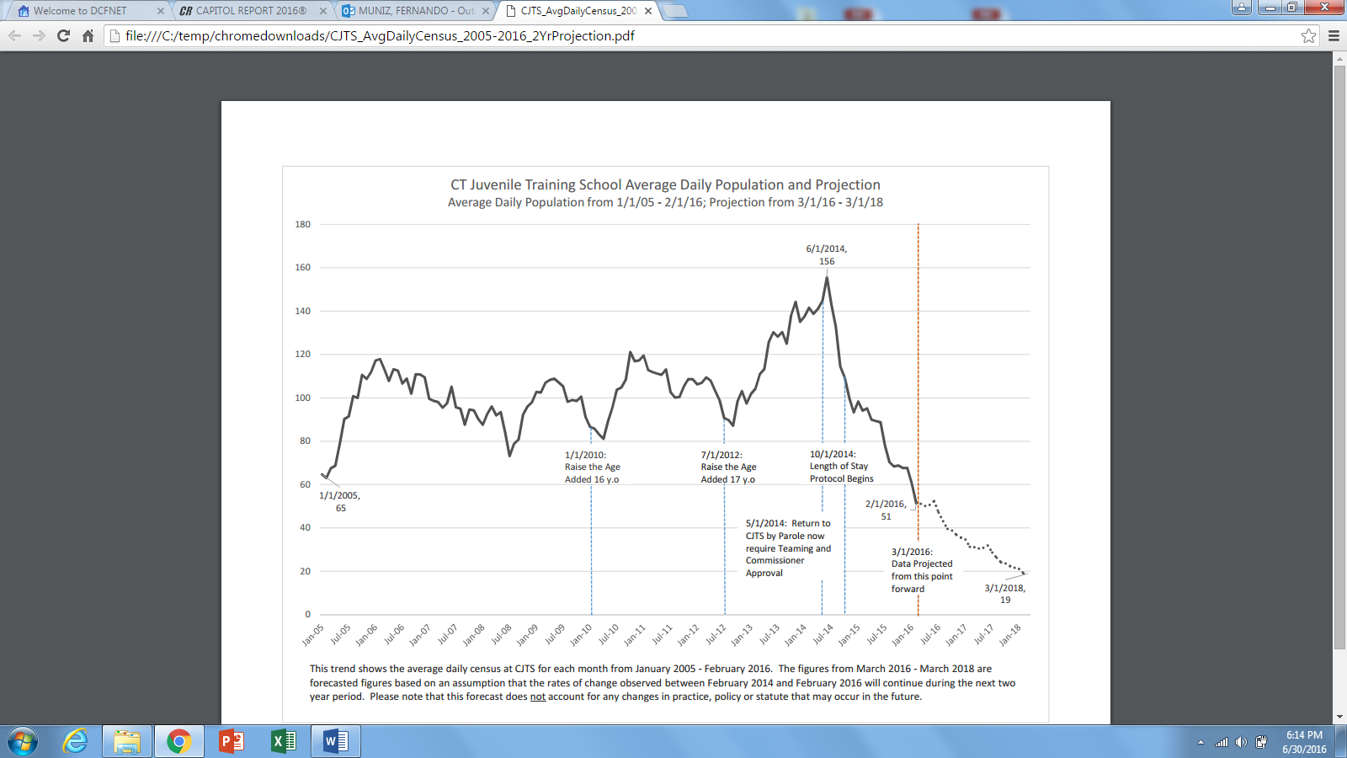

The recent decrease in the census can be attributed to two DCF policy changes that limited the use of secure confinement for some youth:

1. In May 2014, Commissioner Katz issued a directive requiring a teaming process and Commissioner approval before a youth can return to CJTS from the community;
2. In October 2014, CJTS Superintendent Bill Rosenbeck instituted a length of stay protocol with the goal of limiting length of stay to six months for most youth.

Even given these policy changes and trends, however, the census of CJTS has recently averaged approximately 48 youth because of readmissions from the community. Based on the average census, we estimate a future facility or facilities should have the capacity for 40 to 50 youth with the flexibility to downsize if the population continues to decrease. If the age of juvenile court jurisdiction is raised in the future to include young adults up to age twenty, additional facilities would have to be developed to accommodate the increased census. Also, it is unclear what impact the recent statutory changes limiting the use of pre-trial detention may have on the size of the population at CJTS.

**Population Overview**

The overall trend for CJTS admissions has been declining in recent years. There were 176 admissions of 149 unique (male) individuals to CJTS during 2015, compared to 222 admissions of 201 unique individuals in 2014. There were 15 admissions of 11 unique (female) individuals to Pueblo during 2015.

The average age at time of admission was 16.3 years for males (17.0 in 2014) and 17.0 for females (16.5 in 2014).

2015 Calendar year data:

**Table 1: Ages of Youth at Time of Admission**

|  |  |  |
| --- | --- | --- |
| **Age at Admission** | **# Males** | **# Females** |
| **13** | 1 | 0 |
| **14** | 8 | 0 |
| **15** | 26 | 2 |
| **16** | 58 | 2 |
| **17** | 64 | 6 |
| **18** | 17 | 4 |
| **19** | 2 | 1 |
| **Total** | **176** | **15** |

**Table 2: Race/Ethnicity of Admissions**

|  |  |  |  |  |
| --- | --- | --- | --- | --- |
|  | Males Females | | | |
| **Race/Ethnicity** | # | % | # | % |
| African-American | 85 | 48.3% | 2 | 13.3% |
| Hispanic | 49 | 27.8% | 8 | 53.3% |
| Caucasian | 24 | 13.6% | 4 | 26.7% |
| Other | 18 | 10.2% | 1 | 6.7% |
| **Total** | **176** | **100%** | **15** | **100%** |

**Table 3: Primary Adjudication of Admissions**

|  |  |
| --- | --- |
| **Primary Adjudication** | **Admissions** |
| Larceny/Burglary | 41 |
| Weapons Charges | 25 |
| Robbery | 21 |
| Violation of Court Order/Probation | 20 |
| Assault | 18 |
| Narcotics Charges | 12 |
| Breach of Peace | 9 |
| Threatening | 7 |
| Escape from Custody | 4 |
| Sexual Assault | 4 |
| Criminal Trespass | 3 |
| Reckless Endangerment | 3 |
| Bribery | 2 |
| Interfering with Officer/Resisting | 2 |
| Use of Motor Vehicle w/o Permission | 2 |
| Disorderly Conduct | 1 |
| Failure to Appear | 1 |
| Criminal Mischief | 1 |
| Total Admissions | 176 |

**CJTS Closure Plan**

The framework for closure of CJTS is informed by national best practices and consultation the Department of Children and Families has received from national juvenile justice experts. These include:

* the Annie E. Casey Foundation’s framework for reducing juvenile incarceration[1];
* an assessment of DCF’s juvenile justice work conducted by the Georgetown University Center for Juvenile Justice Reform[2];
* a review of the Connecticut Juvenile Justice School conducted by Dr. Robert Kinscherff[3];
* the most recent American Correctional Association accreditation report for CJTS.

In addition to input from national experts, DCF also conducted over 20 focus groups and community meetings with nearly 300 stakeholders across Connecticut. These included:

* the Juvenile Justice Policy and Oversight Committee;
* youth served by the juvenile justice system;
* CJTS and regional juvenile justice staff;
* the Local Interagency Service Teams;
* the DCF State Advisory Council;
* several DCF Regional Advisory Councils;
* the Connecticut Juvenile Justice Alliance Steering Committee;
* the Children’s Behavioral Health Advisory Council.

These community meetings revealed a consensus across Connecticut about the pressing needs of the youth in the juvenile justice system and potential strategies to ensure more youth are served in the community and not in secure confinement. These include preserving services in the following areas:

* job readiness and vocational training;
* substance abuse treatment and recovery supports;
* educational programs, including credit recovery services;
* transitional housing;
* transportation to facilitate family treatment and access to services;
* individualized plans for youth with complex needs;
* programs with longer length of service to address chronic needs;
* better integration of treatment planning and service delivery processes of the secure facility, regional DCF juvenile justice social workers and service providers.

Finally, in June 2016 the Annie E. Casey Foundation’s Juvenile Justice Strategy Group released the results of a survey it conducted with juvenile justice administrators and advocates in jurisdictions across the Unites States. The survey results provide a framework of principles for residential care for youth in secure placement.[4] These principles represent the consensus of juvenile justice experts on a national level of best practices for the operation of secure facilities. They include:

|  |  |  |
| --- | --- | --- |
| **Facility** | **Unit** | **Access/Family** |
| * 50 beds or less * 50 miles from home or less | * 10 kids or less * 1:10 staff/youth ratio or less * No locks on bedrooms * No toilets in bedrooms * All staff = program staff | * Visitation 365 days/year * Transportation 1 time per week * Accessible via public transportation |

|  |  |
| --- | --- |
| **Environment** | **Education** |
| * Youth wear own clothes * Family style meals * Youth/staff help prepare meals together | * Licensed teachers * Unit staff assist in class * Vocation programming * College classes * Credit recovery / GED prep |

Many of these principles have been and/or will be incorporated into the program at CJTS and any future facility that replaces CJTS. Some items, like not having locks on the bedroom doors, will be evaluated based on the security level at any future facilities and the individual needs of the youth.

Based on this scan of national best practices and input from local stakeholders, the strategies for the plan to close CJTS include goals for improving services for youth in the community and goals for improving the experience of youth in secure confinement:

Community-based services goals

|  |  |  |
| --- | --- | --- |
| **GOAL 1**: **Redefine eligibility for secure placement** | | |
| **Action Step** | **Responsible** | **Timeframe** |
| Formalize teaming practices regarding parole re-admissions to CJTS in DCF policy | Legal Division |  |
| Work with CSSD to ensure 100% of youth committed delinquent have been assessed with the JAG | Division of Adolescent & Juvenile Services; CSSD |  |
| Use the YLS Screener at CJTS Intake | CJTS Administration |  |
| Use the YLS for treatment planning and placement decisions | CJTS Administration; DCF Regional Administrators |  |

|  |  |  |
| --- | --- | --- |
| **GOAL 2**: **Improve community supervision of youth** | | |
| **Action Step** | **Responsible** | **Timeframe** |
| Revise the functional job description of JJ social workers | Human Resources Division |  |
| Implement more frequent visitation standards based on a Structured Decision Making matrix | DCF Regional Administrators |  |
| Implement intensive community services, such as Roca | Division of Adolescent & Juvenile Services |  |

|  |  |  |
| --- | --- | --- |
| **GOAL 3**: **Increase access/availability of non-residential community-based services** | | |
| **Action Step** | **Responsible** | **Timeframe** |
| Enhance vocational training and employment opportunities at CJTS and in the community | Division of Adolescent & Juvenile Services;  Unified School District 2; Regional Systems Program Directors |  |
| Enhance access to substance abuse treatment and recovery supports | Division of Adolescent & Juvenile Services;  Division of Clinical and Community Consultation and Support; Regional Systems Program Directors |  |
| Develop housing programs and options for juvenile justice involved youth | Division of Adolescent & Juvenile Services; Regional Systems Program Directors |  |
| Ensure juvenile justice involved youth have access to DCF’s broad array of services through wrap-around funding for unique service expenditures | Division of Clinical and Community Consultation and Support;  Fiscal Services Division; Regional Systems Program Directors |  |
| Amend key juvenile justice contracts to allow services to remain in place after the end of delinquency commitment within existing appropriations | Division of Adolescent & Juvenile Services;  Division of Grants and Contracts |  |
| Develop an intensive wrap-around teaming process for young women who would otherwise be placed in secure confinement | Division of Adolescent & Juvenile Services (with consultation from national experts) |  |

Closure Goals

|  |  |  |
| --- | --- | --- |
| **GOAL 4: Right-size the Connecticut Juvenile Training School** | | |
| **Action Step** | **Responsible** | **Timeframe** |
| Right-size staffing for smaller census | Human Resources Division;  CJTS Administration | Complete |
| Consolidate CJTS programming to three units | CJTS Administration | Complete |

|  |  |  |
| --- | --- | --- |
| **GOAL 5**: **Redesign CJTS programming** | | |
| **Action Step** | **Responsible** | **Timeframe** |
| Ensure better integration of facility, regional and service provider treatment planning | CJTS Administration;  Division of Adolescent & Juvenile Services |  |
| Ensure better integration of providers in the discharge planning process | CJTS Administration |  |
| Change Youth Service Officer job description to promote more involvement in treatment planning | Human Services Division;  Department of Administrative Services |  |
| Expand evening and weekend programming | CJTS Administration |  |
| Provide transportation to facilitate family engagement and family therapy | CJTS Administration |  |
| Incorporate elements of the Annie E. Casey Foundation’s principles of residential care for youth in secure confinement, as appropriate by risk and needs of the population served at CJTS | CJTS Administration |  |
| Enhance CJTS outcomes reporting, including data by race/ethnicity and age | CJTS Administration;  Office for Research and Evaluation |  |

|  |  |  |
| --- | --- | --- |
| **GOAL 6**: **Replace CJTS secure capacity at an alternate setting(s)** | | |
| **Action Step** | **Responsible** | **Timeframe** |
| Host forums for service providers to review data on the population of youth served at CJTS and explore options for serving some of them through contracted services | DCF Commissioner’s Office; Casey Family Programs |  |
| Identify alternate site(s) from surplus state property list and modify them to meet the programmatic needs of youth currently served by CJTS, including both hardware secure and staff secure units | Engineering Division; Office of Policy and Management; DAS Construction Services |  |
| Develop a plan for modifying CJTS if alternate locations cannot be found | Engineering Division; Office of Policy and Management; DAS Construction Services |  |

1. Mendel, Richard A. *No Place for Kids: The Case for Reducing Juvenile Incarceration.* Baltimore, MD: Annie E. Casey Foundation, 2011. Print.
2. Kelly, Marior R., James C. Howell and Kristen Johnson. *Final Report for the State of Connecticut Department of Children and Families*. Washington, DC: Georgetown University Center for Juvenile Justice Reform, 2013. Print.
3. Kinscherff, Robert. *Strategic Review of CJTS/Pueblo Girls Program Policies and Practices.* Delmar, NY: National Center for Mental Health and Juvenile Justice, 2015. Print.
4. Balis, Nate. AECF Principles of Residential Care [PowerPoint slides]. Baltimore, MD: Annie E. Casey Foundation, 2016.