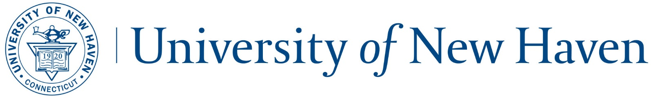Accepted Student Checklist

Congratulations on your acceptance to the University of New Haven! We put together a checklist for new Graduate Students that we hope will help make your transition to graduate school easy.

* 1. Review your acceptance packet and contact us with any questions 203-932-7440 or [gradinfo@newhaven.edu](mailto:gradinfo@newhaven.edu)
* 2. Pay your Commitment Deposit
  + Once the deposit is received, you will receive your student ID and password to gain access to the “MyCharger” portal. Submit your deposit at [www.newhaven.edu/graddeposit](http://www.newhaven.edu/graddeposit)
* 3. If you are applying for a loan through financial aid, complete the Free Application for Federal Student Aid (FAFSA)

<http://www.newhaven.edu/admissions/financial-aid/>

* 4. Submit Final Transcripts and Required Documentation
  + If you have been accepted to the university with a condition that you need to submit a ***final*** official transcript before you enroll, this means that the transcript must show that the degree was conferred or completed. After your degree is conferred, please send final, official transcripts from all colleges and universities attended (submitted in sealed, stamped envelopes from the Registrar’s Office, or via the E-Transcript service if applicable). If final transcripts are not received, students will be unable to register.
* 5. Contact Your Academic Advisor for Course Recommendations for the first term and discuss your plan of study.
  + Go to your program page to obtain your advisors contact information
* 6. Experiential Graduate Assistantship Program (EGAP)
  + Our EGAP program is highly competitive and extremely selective. When the faculty committee reviews the applicant’s admission folder, they will determine whether they believe an applicant is a good candidate for an assistantship. Applicants who are selected as candidates will be individually notified by email. If you were notified that you were selected as a candidate for the highly selective Graduate Assistantship program, please note that the process is similar to applying for a job. You will wait to hear from the assistantship supervisor if he or she believes you are a good fit for the position. Not all candidates will receive an interview, and not all interviewees will receive an assistantship.
* 7. Log In Information for “MyCharger” Portal

You will receive two separate emails, one with your username and one with your password within 24-48 hours from when you receive a decision on your acceptance. The username and password will be used to log into the university’s “MyCharger” portal for email access, registration, course information, and much more.

* 8. “MyCharger” Portal-The following items can be retrieved or completed through the MyCharger Portal:

a. Submit Proof of Physical Exam and Required Immunizations

* + New students are not able to register for classes until the health service paperwork is complete and submitted. The state of Connecticut requires by law that immunization records (part-time and full-time students) and physicals (full-time students) are complete and completed prior to new students attending classes.
  + Full time status = 9+ credits per term  
    If health services paperwork is not received, students will be unable to register. Visit MyCharger to obtain the forms.

b. Register for Classes

* + Visit MyCharger to register in the Self Service Banner system.

c. Campus Card ID-Submit Photo

* + Visit MyCharger for more information on how to obtain your Campus Card

d. Parking Information and Permit Registration

Every August, the new Academic Year parking permit registration information is loaded in MyCharger and you can register for your permit and learn about parking on campus.

e. Pay tuition and review UNH Health Insurance requirements

* + Pay tuition online at MyCharger’s “Epay” link or send payment directly to:  
    University of New Haven  
    Bursar’s Office  
    300 Boston Post Road  
    West Haven, CT 06357
  + Visit MyCharger for instructions on Health Insurance requirements
* 9. Find Housing
  + Visit <https://newhaven.edu/offcampushousing> for details about the brand new university sponsored luxury apartments located just two blocks from campus
  + Visit <https://unewhaven.jumpoffcampus.com/> for information about local rentals
* 10. How to pick up UNH ID (Campus Card) and parking permit
  + You pick up your Campus Card in the back area of the bookstore
  + You must have your Campus Card in order to pick up your parking permit at UNH Police
* 11. Meet with Academic Advisor for planning out your plan of study
  + See enclosed sheet for your advisors contact information

Important Resources for Graduate Students

|  |  |
| --- | --- |
| Bursar’s Office  203.932.7222  [bursar@newhaven.edu](mailto:bursar@newhaven.edu) | Information Technology  [help@newhaven.edu](mailto:help@newhaven.edu) or  [studenttechsupport@newhaven.edu](mailto:studenttechsupport@newhaven.edu) |
| Campus Card (Student IDs and Tech Support)  203.932.7062  [studenttechsupport@newhaven.edu](mailto:studenttechsupport@newhaven.edu) | Office of the University Registrar  203.932.7309  [UNHRegistrar@newhaven.edu](mailto:UNHRegistrar@newhaven.edu) |
| Financial Aid  203.932.7315  [financialaid@newhaven.edu](mailto:financialaid@newhaven.edu) | Student Health Services  203.932.7079 |
| Graduate and International Enrollment  203.932.7440  [gradinfo@newhaven.edu](mailto:gradinfo@newhaven.edu) |  |